How to use this software

1. Open H1-NMR Deconvolutor in the root directory
2. Follow the instructions below

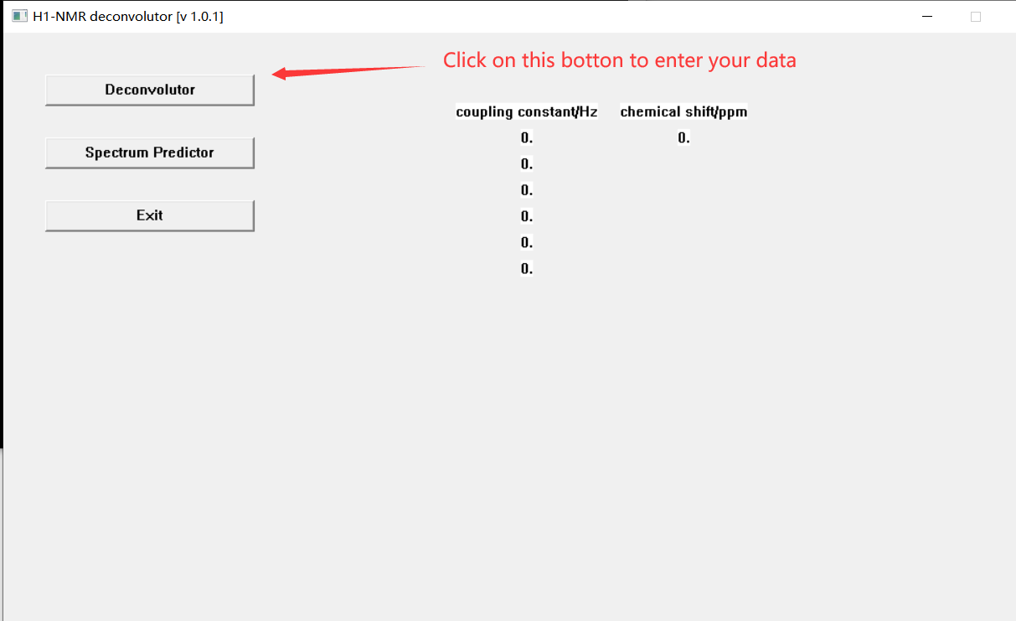

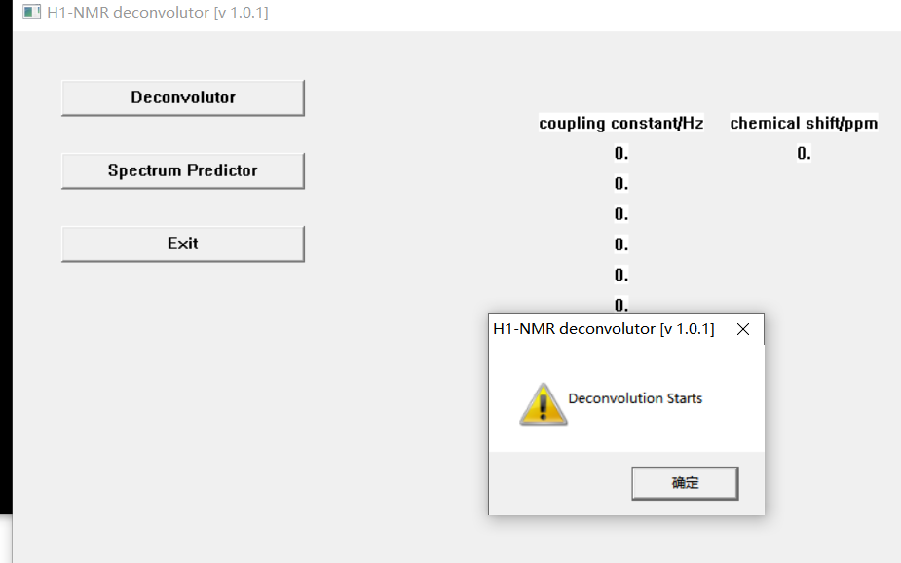

1. Enter your data into the command window and press “enter” to finish your input

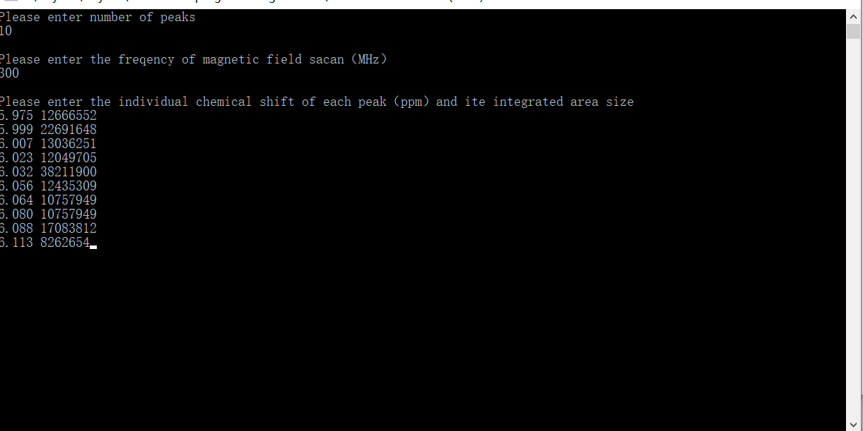

1. A successful example of H1-NMR Deconvolutor (v1.01) en should look like this.

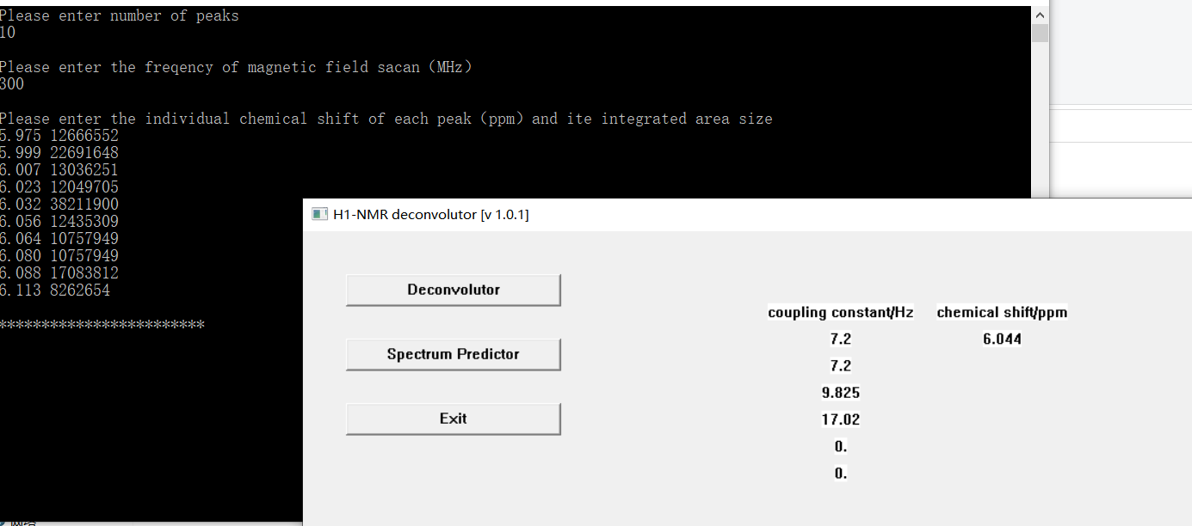

Please refer to main.cpp for the code involved in this project.